Information Technology: Strategy, Infrastructure, Security, and Modern Operations
A harmonized report on IT foundations, management practices, and practical implementation
Prepared as an academic and professional overview
June 25, 2026
Font: Bahnschrift; English text: italic; Layout: compact margins with page numbers
Executive brief: Information technology is the coordinated use of digital infrastructure, software, data, networks, services, controls, and people to support organizational goals. Modern IT is not only a technical department; it is a business capability that shapes customer experience, operational resilience, productivity, risk management, and innovation. This document presents a practical overview of IT as a system of governance, architecture, infrastructure, cloud, cybersecurity, service management, data, software delivery, and future skills.

Contents
1. Role and scope of information technology
2. Governance, value, and operating model
3. Enterprise architecture and infrastructure
4. Networks, endpoints, identity, and operations
5. Cloud computing and hybrid platforms
6. Data management, analytics, and information quality
7. Cybersecurity, privacy, and risk management
8. IT service management and user experience
9. Software delivery, DevOps, and automation
10. Emerging technologies, AI, and the future of IT
11. Implementation roadmap and conclusion
References
List of figures: Figure 1 IT capability stack; Figure 2 Governance cycle; Figure 3 Hybrid cloud operating model; Figure 4 Cybersecurity lifecycle; Figure 5 Incident response flow; Figure 6 Data value pipeline; Figure 7 DevOps feedback loop; Figure 8 IT maturity roadmap.
List of tables: Table 1 Core IT domains and responsibilities; Table 2 Governance decision rights; Table 3 Infrastructure components; Table 4 Cloud service models; Table 5 Security controls by layer; Table 6 Data governance responsibilities; Table 7 Service management metrics; Table 8 Delivery method comparison; Table 9 Risk register; Table 10 Roadmap phases.

1. Role and Scope of Information Technology
Information technology is the disciplined use of computing resources to create, process, transmit, secure, store, and improve information. In an organization, IT links strategy with execution by turning business needs into reliable digital services. These services may be as visible as customer portals and mobile applications or as invisible as identity directories, backup jobs, network routing, monitoring alerts, and data integration flows. The practical value of IT appears when people can work faster, make better decisions, collaborate securely, and recover from disruption without losing confidence in the organization.
The modern scope of IT is broad because digital systems are embedded in almost every business process. Finance depends on enterprise applications and audit trails, operations depend on networks and sensors, marketing depends on customer data, and leadership depends on analytics. For that reason, IT must be understood as a management system, not merely a collection of devices. Figure 1 presents the layered capability stack used throughout this report, and the stack emphasizes that governance, security, and service management support every technical layer rather than standing apart from it.
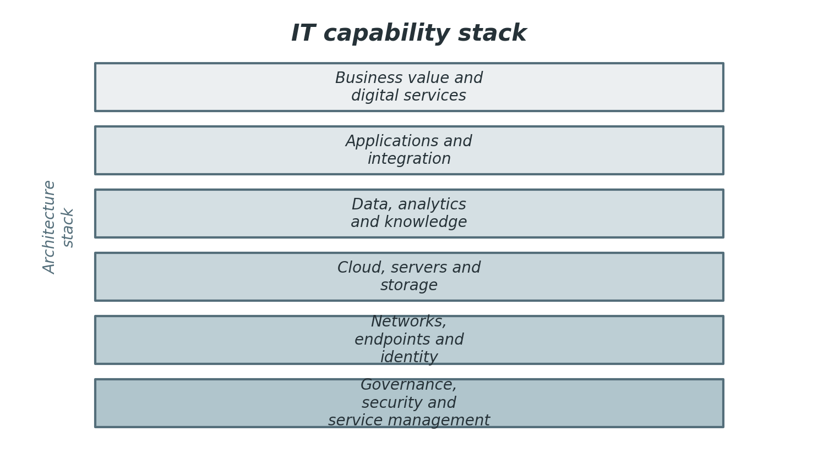
Figure 1. IT capability stack.
Table 1 names the principal domains of IT work and shows how each domain contributes to organizational outcomes. The table also makes clear that responsibilities overlap: infrastructure without governance becomes expensive, applications without data quality become unreliable, and security without service design becomes difficult for users to adopt.
Table 1. Core IT domains and responsibilities.
Domain | Primary responsibility | Typical outputs
Governance | Align technology decisions with goals, risk appetite, funding, and accountability. | Policies, steering decisions, portfolio priorities, value measures.
Architecture | Design coherent platforms, integrations, information flows, and technology standards. | Reference architectures, roadmaps, standards, design reviews.
Infrastructure | Operate compute, storage, networks, endpoints, and platform services reliably. | Servers, cloud resources, networks, images, backup jobs, monitoring.
Applications | Build, configure, integrate, and maintain systems used by employees and customers. | Business applications, APIs, workflows, release packages, documentation.
Data | Ensure information is defined, trusted, governed, available, and useful for decisions. | Data catalogues, quality rules, reports, pipelines, retention schedules.
Security | Protect confidentiality, integrity, availability, privacy, and resilience. | Controls, risk treatment plans, incident playbooks, awareness activities.
Service management | Manage the user experience and the lifecycle of digital services. | Service catalogue, incidents, requests, changes, service level reports.

2. Governance, Value, and Operating Model
Governance gives IT a clear mandate. Without governance, technical teams often optimize local priorities, such as server utilization or application features, while the organization needs broader outcomes, such as faster onboarding, regulatory confidence, resilience, and customer trust. Governance does not mean excessive bureaucracy. It means deciding who has authority, what evidence is required, how trade-offs are evaluated, and how benefits are measured after money and effort have been spent.
Figure 2 shows governance as a feedback cycle rather than a one-time approval gate. Leaders set direction, teams prioritize work, resources are allocated, outcomes are measured, and controls are improved. This cycle helps IT remain adaptive when business conditions, regulations, threats, and vendor ecosystems change. The best governance forums are short, evidence-based, and connected to actual delivery teams; they remove ambiguity instead of merely producing meeting minutes.
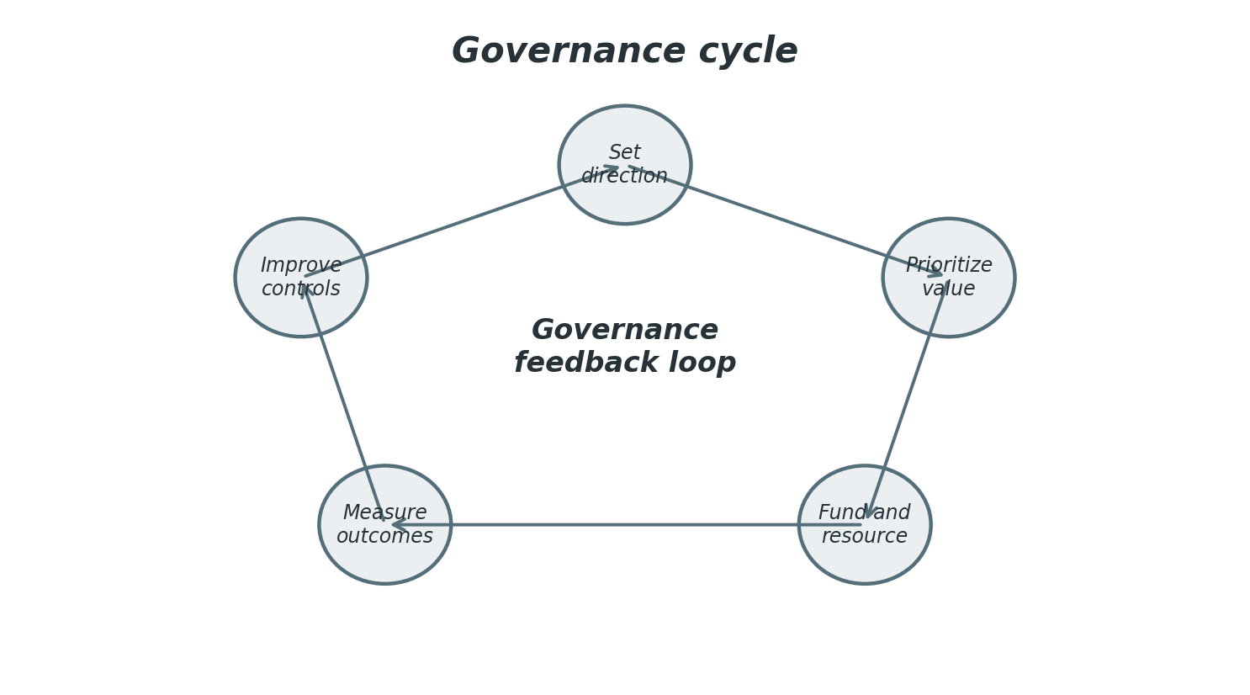
Figure 2. Governance cycle.
A strong operating model connects demand intake, architecture review, funding, delivery, operations, and service improvement. It clarifies whether IT is centralized, federated, product-aligned, or outsourced, and it defines how business units participate in technology decisions. Mature organizations usually blend these patterns. Core platforms may be centralized for security and scale, while product teams may be empowered to deliver features quickly within agreed standards.
Value management is essential because IT costs can be visible while IT benefits are distributed across many departments. Cost transparency should include licenses, cloud consumption, support time, infrastructure, risk reduction, and opportunity cost. Benefits should include productivity, error reduction, risk reduction, customer satisfaction, revenue enablement, and faster cycle time. This balanced view prevents narrow cost cutting that weakens resilience or creates hidden manual work elsewhere.
Governance must also address ethics and accountability. Decisions about monitoring, artificial intelligence, automation, user data, outsourcing, and retention may affect employees and customers. IT governance should therefore include legal, privacy, security, operations, and business voices. This multidisciplinary approach helps organizations balance innovation with trust, compliance, and responsible use of technology.
Table 2 provides a compact reference for the practices discussed in this section and names the table so that it can be cited unambiguously in reviews and presentations.
Table 2. Governance decision rights and evidence.
Decision area | Key question | Evidence of good practice
Strategy alignment | Which business outcomes should IT enable first? | Approved portfolio, value cases, shared roadmaps, executive sponsorship.
Investment | How should funding be allocated across run, grow, and transform work? | Budget model, cost transparency, benefits tracking, prioritization rules.
Risk appetite | Which technology risks are acceptable, transferred, reduced, or avoided? | Risk register, exception process, control ownership, audit trail.
Architecture standards | Which platforms and patterns should be preferred? | Standards catalogue, waiver process, lifecycle management.
Service accountability | Who owns service performance and user experience? | Service owner roles, metrics, escalation paths, review cadence.

Portfolio discipline
A technology portfolio should distinguish mandatory work, risk reduction, product improvement, platform investment, and experimentation. This classification helps leaders compare unlike requests without pretending every item has the same kind of value. Mandatory work may be driven by regulation or contract. Platform investment may not create immediate revenue but can reduce future delivery cost. Experimentation may have uncertain value but reveal important options.
The practical lesson is to connect the topic to ownership, measurement, and continual improvement. A process that is not owned will drift, a platform that is not measured will surprise its operators, and a control that is not reviewed will eventually become either too weak or too burdensome. Harmonious IT management keeps the purpose of each practice visible while adjusting the practice to fit real operating conditions.

Policy as enablement
Policies should explain desired outcomes and decision rules rather than only prohibitions. For example, a cloud policy can define tagging, logging, encryption, identity, region, and backup expectations. When these rules are built into templates and automated checks, policy becomes an accelerator. Teams no longer have to negotiate every detail because the approved path is visible and repeatable.
The practical lesson is to connect the topic to ownership, measurement, and continual improvement. A process that is not owned will drift, a platform that is not measured will surprise its operators, and a control that is not reviewed will eventually become either too weak or too burdensome. Harmonious IT management keeps the purpose of each practice visible while adjusting the practice to fit real operating conditions.

Vendor accountability
Many IT capabilities are now delivered through vendors and managed services. Governance must therefore include supplier selection, contract review, service level monitoring, exit planning, data handling requirements, and security assurance. Vendor management is not a procurement formality; it is part of operational risk management because external dependencies can affect continuity, privacy, and customer trust.
The practical lesson is to connect the topic to ownership, measurement, and continual improvement. A process that is not owned will drift, a platform that is not measured will surprise its operators, and a control that is not reviewed will eventually become either too weak or too burdensome. Harmonious IT management keeps the purpose of each practice visible while adjusting the practice to fit real operating conditions.

3. Enterprise Architecture and Infrastructure
Enterprise architecture provides the structure that lets many technology decisions become one coherent environment. It describes business capabilities, applications, data entities, integrations, infrastructure, security patterns, and lifecycle states. The architecture function should not be limited to diagrams. It should help teams choose reusable patterns, reduce duplication, manage technical debt, and make change safer. Architecture is most useful when it is lightweight enough to support delivery and disciplined enough to prevent avoidable complexity.
Infrastructure is the operational foundation of digital services. It includes compute, storage, networks, endpoints, identity platforms, backup systems, monitoring tools, automation scripts, and environmental controls. In many organizations, infrastructure now spans on-premises data centers, public cloud providers, managed services, and software-as-a-service environments. This distribution increases flexibility but also requires better inventory, configuration management, access control, and cost governance.
Infrastructure decisions should be based on workload requirements. A customer-facing payment system may require high availability, strict monitoring, encryption, and tested failover. An internal reporting sandbox may tolerate more downtime but require strong data handling rules. Standardizing patterns reduces support effort and helps security teams apply controls consistently. At the same time, standards should allow exceptions when justified by risk and value.
Technical debt appears when short-term choices increase future effort. Examples include unsupported operating systems, undocumented integrations, one-off scripts, poorly configured cloud resources, and applications that only one person understands. Debt is not always bad; sometimes a temporary solution is rational. The governance problem is unmanaged debt. Good IT organizations keep debt visible, assign owners, estimate risk, and schedule remediation before debt becomes operational fragility.
A harmonious infrastructure environment is observable, documented, and recoverable. Observability means teams can understand service health from metrics, logs, traces, synthetic checks, and user feedback. Documentation means dependencies, ownership, and operating procedures are discoverable. Recoverability means backups, failover, and incident procedures are tested rather than assumed. These qualities are often more important than any single technology product.
Table 3 provides a compact reference for the practices discussed in this section and names the table so that it can be cited unambiguously in reviews and presentations.
Table 3. Infrastructure components and design considerations.
Component | Purpose | Design consideration
Compute | Runs workloads through physical servers, virtual machines, containers, or serverless services. | Match performance, availability, security, and cost to workload criticality.
Storage | Persists files, databases, backups, logs, and object data. | Classify data, define retention, test restore processes, and monitor capacity.
Network | Connects users, devices, sites, applications, and cloud services. | Segment traffic, monitor latency, protect remote access, document dependencies.
Identity | Authenticates users, devices, services, and administrators. | Use least privilege, strong authentication, privileged access controls, and reviews.
Monitoring | Observes availability, performance, security signals, and user experience. | Correlate logs, alerts, traces, metrics, and service dependencies.
Backup and recovery | Restores services and data after error, failure, attack, or disaster. | Define recovery objectives, protect backups, and rehearse restoration.

Documentation that stays useful
Architecture documentation should be concise, versioned, and connected to decisions. Diagrams that no one trusts create confusion. Useful documentation identifies owners, interfaces, data flows, environments, security zones, dependencies, and lifecycle status. It should be updated through normal change and delivery processes, not as a separate ceremonial task after systems are already in production.
The practical lesson is to connect the topic to ownership, measurement, and continual improvement. A process that is not owned will drift, a platform that is not measured will surprise its operators, and a control that is not reviewed will eventually become either too weak or too burdensome. Harmonious IT management keeps the purpose of each practice visible while adjusting the practice to fit real operating conditions.

Configuration management
Configuration management records what exists and how components relate to services. Asset lists alone are not enough because operations teams need to know dependencies. A database server may support several applications, a certificate may protect a customer portal, and a network rule may enable a critical integration. Understanding these relationships helps teams assess change impact and respond to incidents faster.
The practical lesson is to connect the topic to ownership, measurement, and continual improvement. A process that is not owned will drift, a platform that is not measured will surprise its operators, and a control that is not reviewed will eventually become either too weak or too burdensome. Harmonious IT management keeps the purpose of each practice visible while adjusting the practice to fit real operating conditions.

Capacity and performance
Capacity management should combine technical monitoring with business forecasting. A system may be healthy under current load but unprepared for a campaign, acquisition, seasonal peak, or regulatory deadline. Performance engineering includes architecture choices, database design, caching, network latency, resource allocation, and application behavior. Measuring from the user perspective prevents teams from optimizing internal metrics that do not improve experience.
The practical lesson is to connect the topic to ownership, measurement, and continual improvement. A process that is not owned will drift, a platform that is not measured will surprise its operators, and a control that is not reviewed will eventually become either too weak or too burdensome. Harmonious IT management keeps the purpose of each practice visible while adjusting the practice to fit real operating conditions.

4. Networks, Endpoints, Identity, and Operations
Networks connect people, devices, applications, and services, but their role has changed. Traditional network design often assumed a trusted internal perimeter and an untrusted external internet. Modern work patterns, cloud services, remote access, mobile devices, contractors, and supply-chain integrations weaken that assumption. Network architecture now needs segmentation, strong identity integration, encrypted communication, and continuous monitoring across internal and external environments.
Endpoints remain one of the most visible parts of IT because users experience them directly. A laptop that starts quickly, updates reliably, connects securely, and supports collaboration tools can improve productivity every day. A poorly managed endpoint can become a source of frustration and risk. Endpoint management therefore combines standard images, patching, device health monitoring, encryption, malware protection, self-service tools, and clear lifecycle replacement planning.
Identity is a core security and productivity service. It controls who can access systems, what roles they have, how privileges are approved, and how access is removed when roles change. Strong identity management uses multi-factor authentication, conditional access, single sign-on, privileged access management, periodic reviews, and automation for joiner, mover, and leaver processes. Identity also extends to services, APIs, devices, and automation accounts, not only human users.
Operations teams keep services reliable by managing incidents, events, jobs, capacity, performance, backups, certificates, vulnerabilities, and changes. The best operations work is often invisible because it prevents issues before users notice them. Runbooks, monitoring thresholds, escalation paths, and post-incident reviews are practical tools for creating repeatable operations. Automation should be used where it reduces manual error and frees specialists to solve higher-value problems.
Operational excellence requires balance. Excessive change control can delay useful improvements, but uncontrolled change creates outages. Too many alerts can hide real problems, but too few alerts delay response. Highly customized endpoints can please individual preferences, but they increase support complexity. IT leaders should therefore define operating principles, measure actual outcomes, and continuously adjust controls based on evidence.

Documentation that stays useful
Architecture documentation should be concise, versioned, and connected to decisions. Diagrams that no one trusts create confusion. Useful documentation identifies owners, interfaces, data flows, environments, security zones, dependencies, and lifecycle status. It should be updated through normal change and delivery processes, not as a separate ceremonial task after systems are already in production.
The practical lesson is to connect the topic to ownership, measurement, and continual improvement. A process that is not owned will drift, a platform that is not measured will surprise its operators, and a control that is not reviewed will eventually become either too weak or too burdensome. Harmonious IT management keeps the purpose of each practice visible while adjusting the practice to fit real operating conditions.

Configuration management
Configuration management records what exists and how components relate to services. Asset lists alone are not enough because operations teams need to know dependencies. A database server may support several applications, a certificate may protect a customer portal, and a network rule may enable a critical integration. Understanding these relationships helps teams assess change impact and respond to incidents faster.
The practical lesson is to connect the topic to ownership, measurement, and continual improvement. A process that is not owned will drift, a platform that is not measured will surprise its operators, and a control that is not reviewed will eventually become either too weak or too burdensome. Harmonious IT management keeps the purpose of each practice visible while adjusting the practice to fit real operating conditions.

Capacity and performance
Capacity management should combine technical monitoring with business forecasting. A system may be healthy under current load but unprepared for a campaign, acquisition, seasonal peak, or regulatory deadline. Performance engineering includes architecture choices, database design, caching, network latency, resource allocation, and application behavior. Measuring from the user perspective prevents teams from optimizing internal metrics that do not improve experience.
The practical lesson is to connect the topic to ownership, measurement, and continual improvement. A process that is not owned will drift, a platform that is not measured will surprise its operators, and a control that is not reviewed will eventually become either too weak or too burdensome. Harmonious IT management keeps the purpose of each practice visible while adjusting the practice to fit real operating conditions.

5. Cloud Computing and Hybrid Platforms
Cloud computing gives organizations on-demand access to configurable resources that can be provisioned and released with less direct management effort. In practice, cloud adoption changes more than hosting location. It changes financial management, architecture, security responsibilities, vendor management, service continuity, and skills. Teams must understand shared responsibility: the provider secures and operates some layers, while the customer remains accountable for configuration, identity, data protection, access, and use.
Figure 3 illustrates that many organizations operate a hybrid model rather than a pure public cloud or pure data center model. Users, branches, private platforms, public cloud services, SaaS applications, and identity providers must work together. The architectural challenge is to make the experience reliable and secure while avoiding uncontrolled sprawl. Hybrid integration requires network design, identity federation, data protection, monitoring, and consistent change management.
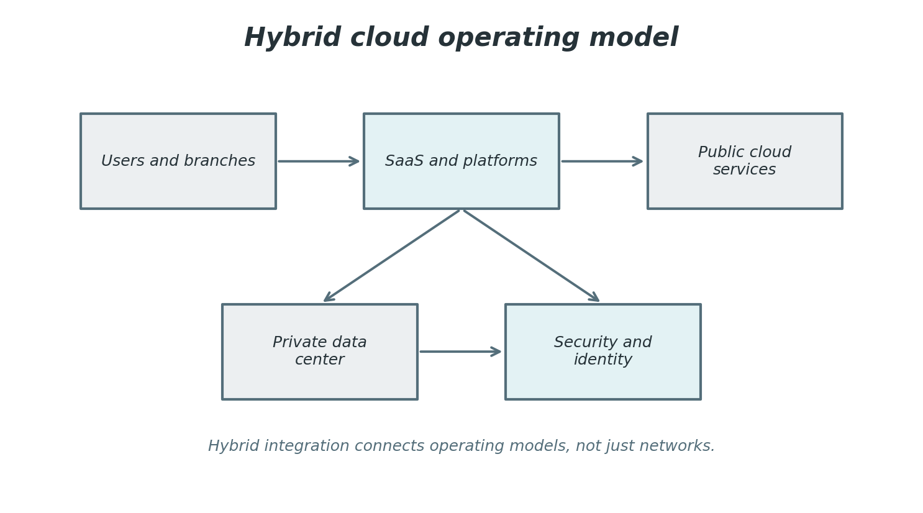
Figure 3. Hybrid cloud operating model.
Cloud benefits include elasticity, faster provisioning, global reach, managed services, and reduced need for capital investment. Cloud risks include misconfiguration, unexpected consumption costs, vendor concentration, data residency constraints, service dependency, and skill gaps. A mature cloud program includes landing zones, policy guardrails, tagging standards, cost management, reference architectures, workload placement criteria, and a review process for high-risk designs.
Workload placement should be intentional. Some workloads belong in SaaS because standard functionality is sufficient and speed matters. Some belong in public cloud because they need scalability, analytics, or global deployment. Some remain on premises because of latency, legacy dependencies, specialized equipment, or regulatory conditions. The goal is not to put everything in one place; the goal is to place each workload where it delivers the best balance of value, control, resilience, and cost.
Cloud operating models should include financial operations, commonly called FinOps. Consumption-based pricing can be powerful, but it requires visibility, ownership, and active optimization. Good practices include budget alerts, rightsizing, reserved capacity where appropriate, cleanup of unused resources, chargeback or showback reports, and architectural reviews that consider cost before production deployment.
Table 4 provides a compact reference for the practices discussed in this section and names the table so that it can be cited unambiguously in reviews and presentations.
Table 4. Cloud service models and typical use.
Model | What the provider manages | Common use
Infrastructure as a service | Physical facilities, hardware, virtualization, and core platform availability. | Flexible compute, storage, development environments, disaster recovery.
Platform as a service | Runtime platform, middleware, scaling features, and managed developer services. | Web applications, APIs, integration services, analytics pipelines.
Software as a service | Full application stack, updates, hosting, and standard service availability. | Email, collaboration, CRM, HR, finance, ticketing, document management.
Serverless and managed services | Event runtime, scaling, operations, and many platform tasks. | Event processing, integration, automation, lightweight application functions.

Landing zones and guardrails
A cloud landing zone provides a prepared environment with identity, network, logging, security, cost controls, and deployment patterns. Guardrails let teams move quickly while remaining inside acceptable boundaries. Examples include approved regions, required encryption, mandatory tags, blocked public storage, centralized logging, and automated policy checks. This approach is usually more effective than reviewing every cloud resource manually.
The practical lesson is to connect the topic to ownership, measurement, and continual improvement. A process that is not owned will drift, a platform that is not measured will surprise its operators, and a control that is not reviewed will eventually become either too weak or too burdensome. Harmonious IT management keeps the purpose of each practice visible while adjusting the practice to fit real operating conditions.

Shared responsibility
Shared responsibility should be understood by managers as well as engineers. A provider may secure the physical data center and underlying services, but customers still configure access, protect data, manage identities, monitor usage, and design recovery. Misunderstanding this boundary is a common source of risk. Contracts and architecture documents should make responsibilities explicit.
The practical lesson is to connect the topic to ownership, measurement, and continual improvement. A process that is not owned will drift, a platform that is not measured will surprise its operators, and a control that is not reviewed will eventually become either too weak or too burdensome. Harmonious IT management keeps the purpose of each practice visible while adjusting the practice to fit real operating conditions.

Cloud economics
Cloud cost is not only a monthly invoice. It reflects architecture, usage patterns, data transfer, storage tiers, logging volume, support plans, licensing, and unused resources. A service that is cheap in development may become expensive at scale. Cost-aware design uses forecasting, tagging, rightsizing, autoscaling, scheduled shutdown, reserved capacity where appropriate, and regular cleanup.
The practical lesson is to connect the topic to ownership, measurement, and continual improvement. A process that is not owned will drift, a platform that is not measured will surprise its operators, and a control that is not reviewed will eventually become either too weak or too burdensome. Harmonious IT management keeps the purpose of each practice visible while adjusting the practice to fit real operating conditions.

6. Data Management, Analytics, and Information Quality
Data is one of the most valuable outputs and inputs of IT. Applications generate data, users interpret data, leaders act on data, and customers increasingly expect data-driven experiences. Yet data only creates value when it is trusted. Trust depends on definitions, quality, lineage, access controls, privacy, retention, and context. A number in a dashboard is useful only when people know what it means, where it came from, how current it is, and whether it can be used for the decision at hand.
Figure 6 shows the data value pipeline from source systems to decisions. Data must be ingested, stored, transformed, analyzed, and converted into action. Each stage introduces risk. Source data may be incomplete, pipelines may fail silently, transformations may use outdated rules, dashboards may be misread, and decisions may not create feedback for improvement. Good data management therefore combines technology controls with business ownership.
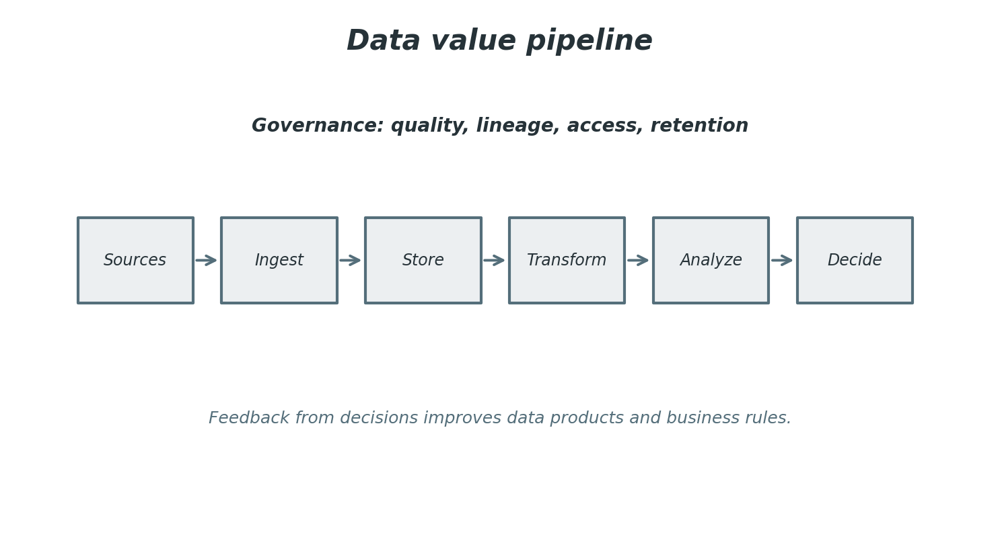
Figure 6. Data value pipeline.
Information quality has several dimensions: accuracy, completeness, timeliness, consistency, uniqueness, validity, and fitness for purpose. Not every dataset needs the same level of quality. A regulatory report needs strict reconciliation and retention. A prototype dashboard may tolerate uncertainty if it is clearly labeled. Quality requirements should be attached to business use, because over-engineering every dataset wastes effort while under-controlling critical data creates risk.
Analytics maturity often progresses from descriptive reporting to diagnostic analysis, predictive modeling, and prescriptive recommendations. The progression requires better data integration, stronger governance, more advanced skills, and clearer accountability for decisions. Artificial intelligence and machine learning add additional needs: model monitoring, bias assessment, explainability, secure training data, and careful consideration of how automated recommendations affect people.
Data governance should be practical. A glossary no one uses, a catalogue no one updates, and a policy no one understands do not create trust. Effective governance connects metadata to real workflows such as access requests, dashboard certification, data quality issue resolution, retention decisions, and project design reviews. This keeps governance close to delivery and helps users understand why good data practices matter.
Table 6 provides a compact reference for the practices discussed in this section and names the table so that it can be cited unambiguously in reviews and presentations.
Table 6. Data governance responsibilities.
Role | Responsibility | Practical artifact
Data owner | Accountable for meaning, use, access, and lifecycle of a data domain. | Data policy, access approval, quality objectives.
Data steward | Maintains definitions, quality rules, metadata, and issue resolution. | Glossary, data quality dashboard, issue log.
Data engineer | Builds pipelines, transformations, storage structures, and automation. | Pipeline code, schema, orchestration jobs, lineage notes.
Data analyst | Turns data into reports, insights, and business recommendations. | Dashboards, analytical models, decision briefs.
Security and privacy lead | Ensures controls for access, retention, encryption, and lawful use. | Classification rules, privacy impact notes, control evidence.

Master data and reference data
Master data represents core business entities such as customers, products, suppliers, employees, and locations. Reference data provides standard values such as country codes, status codes, and categories. Poor master and reference data causes reconciliation errors, duplicate work, inconsistent reporting, and weak customer experience. Governance should assign ownership and define how authoritative sources are maintained.
The practical lesson is to connect the topic to ownership, measurement, and continual improvement. A process that is not owned will drift, a platform that is not measured will surprise its operators, and a control that is not reviewed will eventually become either too weak or too burdensome. Harmonious IT management keeps the purpose of each practice visible while adjusting the practice to fit real operating conditions.

Retention and disposal
Keeping data forever creates cost and risk. Retention schedules should reflect legal, operational, historical, and analytical needs. Disposal should be controlled and auditable, especially for sensitive information. In cloud and SaaS environments, teams must understand where data is stored, how backups behave, and whether deletion in an application also removes copies from exports, archives, or downstream systems.
The practical lesson is to connect the topic to ownership, measurement, and continual improvement. A process that is not owned will drift, a platform that is not measured will surprise its operators, and a control that is not reviewed will eventually become either too weak or too burdensome. Harmonious IT management keeps the purpose of each practice visible while adjusting the practice to fit real operating conditions.

Analytics adoption
Dashboards create value only when they are used in decisions. Adoption improves when reports answer real questions, definitions are clear, performance is acceptable, and users trust the data. Training should focus on interpretation and action, not just interface navigation. Teams should periodically retire unused reports so that the analytics environment remains understandable.
The practical lesson is to connect the topic to ownership, measurement, and continual improvement. A process that is not owned will drift, a platform that is not measured will surprise its operators, and a control that is not reviewed will eventually become either too weak or too burdensome. Harmonious IT management keeps the purpose of each practice visible while adjusting the practice to fit real operating conditions.

7. Cybersecurity, Privacy, and Risk Management
Cybersecurity protects confidentiality, integrity, availability, privacy, and resilience. It is not a single tool, team, or compliance checklist. It is a risk management discipline that combines governance, technology, process, behavior, supplier assurance, and recovery capability. Security must be built into architecture and operations because threats exploit weak points across identity, endpoints, applications, cloud services, data, and human behavior.
Figure 4 uses the NIST Cybersecurity Framework 2.0 functions to present security as a lifecycle: Govern, Identify, Protect, Detect, Respond, and Recover. This structure is helpful because it avoids an overly narrow focus on prevention. Mature security programs set direction, understand assets and risks, implement safeguards, detect abnormal activity, respond effectively, and restore operations while learning from events.
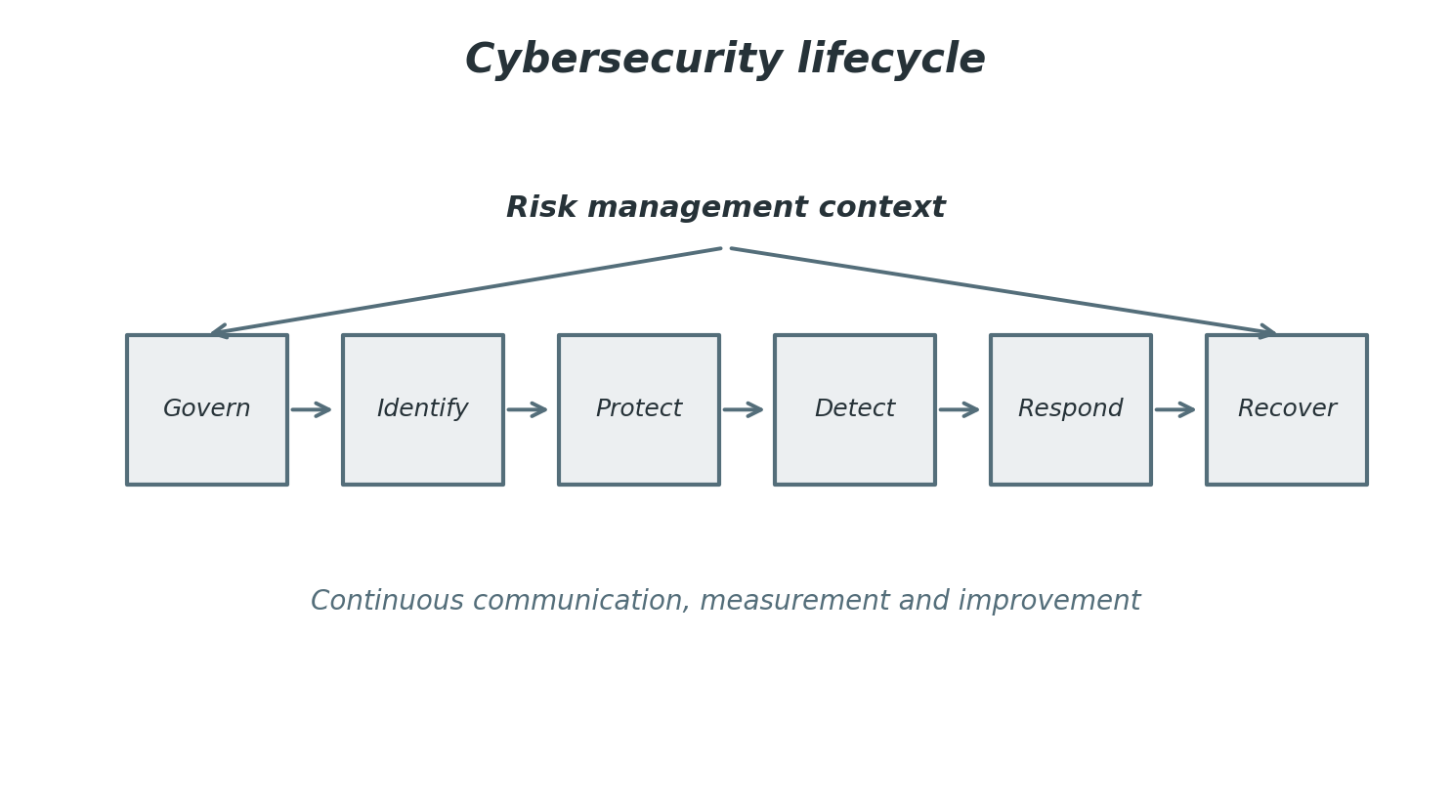
Figure 4. Cybersecurity lifecycle.
Risk management begins with context. The same vulnerability can have different priority depending on exposure, business criticality, data sensitivity, compensating controls, exploit activity, and recovery capability. A public internet-facing system with customer data requires faster treatment than a low-value internal test system. Good risk registers show ownership, likelihood, impact, treatment decision, due date, and residual risk, not just technical severity.
Privacy complements cybersecurity but is not identical to it. Security asks how information is protected; privacy also asks whether information should be collected, how it may be used, who is informed, how long it is retained, and how rights or expectations are honored. IT teams support privacy through data minimization, access controls, retention automation, audit trails, encryption, consent management, and secure disposal.
Human factors are central to cybersecurity. Users can be targeted through phishing, social engineering, credential theft, and unsafe workarounds. Security awareness should therefore be practical and respectful rather than punitive. Teams should make secure behavior easier through single sign-on, password managers, clear reporting channels, useful training, and rapid support. Culture improves when people believe reporting a mistake will lead to help and learning instead of blame.
Table 5 provides a compact reference for the practices discussed in this section and names the table so that it can be cited unambiguously in reviews and presentations.
Table 5. Security controls by layer.
Layer | Control examples | Management focus
Identity | Multi-factor authentication, conditional access, privileged access management. | Ensure the right people and services have the right access for the right time.
Endpoint | Hardening, encryption, patching, endpoint detection and response. | Reduce attack surface and improve visibility on user devices and servers.
Network | Segmentation, secure remote access, firewalls, intrusion detection. | Limit lateral movement and protect traffic between zones.
Application | Secure coding, testing, dependency management, secrets handling. | Reduce vulnerabilities before and after release.
Data | Classification, encryption, loss prevention, retention controls. | Protect sensitive information throughout its lifecycle.
Operations | Logging, monitoring, vulnerability management, incident response. | Detect, respond, recover, and continuously improve.

Control depth
Security controls work best in layers. If a phishing email succeeds, strong authentication can reduce account takeover. If an endpoint is compromised, segmentation can limit lateral movement. If data is reached, encryption and monitoring can reduce impact and improve detection. Layering controls recognizes that no single safeguard is perfect and that resilience depends on multiple opportunities to prevent, detect, and recover.
The practical lesson is to connect the topic to ownership, measurement, and continual improvement. A process that is not owned will drift, a platform that is not measured will surprise its operators, and a control that is not reviewed will eventually become either too weak or too burdensome. Harmonious IT management keeps the purpose of each practice visible while adjusting the practice to fit real operating conditions.

Vulnerability management
Vulnerability management requires inventory, scanning, prioritization, remediation, exception handling, and verification. The most useful programs prioritize based on exploitability, exposure, business criticality, and compensating controls. Patching everything immediately is rarely possible, so teams need risk-based queues and clear ownership. Metrics should show aging, recurrence, critical exposure, and remediation effectiveness.
The practical lesson is to connect the topic to ownership, measurement, and continual improvement. A process that is not owned will drift, a platform that is not measured will surprise its operators, and a control that is not reviewed will eventually become either too weak or too burdensome. Harmonious IT management keeps the purpose of each practice visible while adjusting the practice to fit real operating conditions.

Security evidence
Compliance efforts are stronger when evidence is produced by normal operations. Examples include access review records, backup test results, change logs, vulnerability dashboards, training completion, incident exercises, and configuration baselines. Evidence should tell the story of control operation, not merely show that a document exists. This approach reduces audit stress and improves actual security.
The practical lesson is to connect the topic to ownership, measurement, and continual improvement. A process that is not owned will drift, a platform that is not measured will surprise its operators, and a control that is not reviewed will eventually become either too weak or too burdensome. Harmonious IT management keeps the purpose of each practice visible while adjusting the practice to fit real operating conditions.

8. Incident Response, Continuity, and Resilience
Incidents are events that threaten or disrupt normal service, security, or business operation. They may include system outages, data loss, ransomware, account compromise, failed changes, performance degradation, or supplier failures. Incident response is the coordinated ability to detect, assess, contain, recover, communicate, and learn. It should be planned before an incident occurs because pressure, uncertainty, and incomplete information make improvised response unreliable.
Figure 5 presents incident response as a flow with feedback. Detection leads to triage, containment, eradication, recovery, and learning. The learning step is essential because an organization that restores service but does not improve controls remains exposed. Post-incident reviews should identify technical causes, process gaps, communication issues, decision delays, monitoring weaknesses, and recovery constraints. The tone should focus on improvement rather than blame.
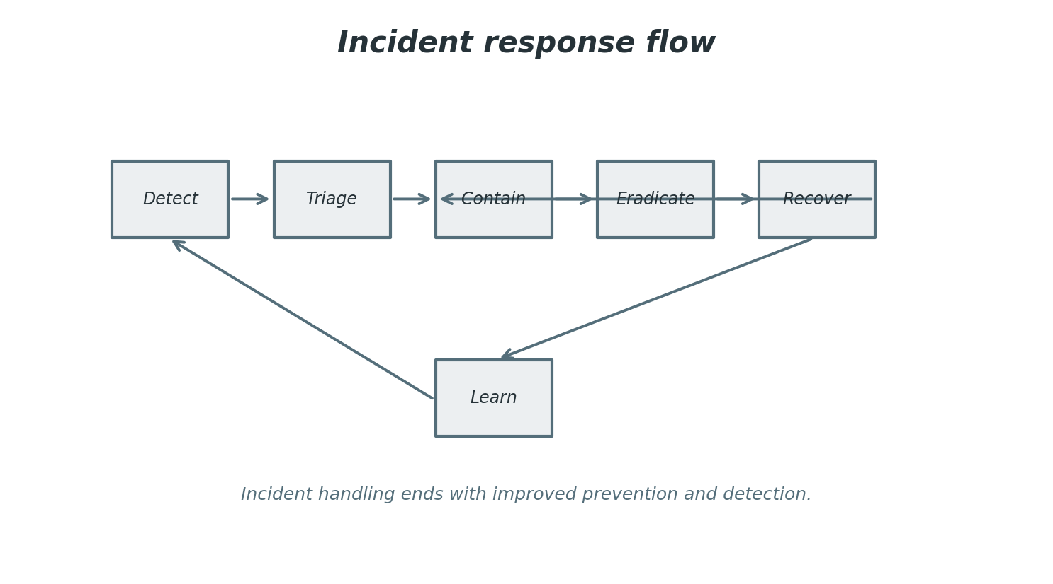
Figure 5. Incident response flow.
Continuity planning defines how essential services continue or recover during disruption. It requires business impact analysis, recovery time objectives, recovery point objectives, dependency mapping, alternate procedures, contact lists, and periodic exercises. Technical recovery is only part of continuity. People need roles, decision rights, communication templates, and escalation paths. Suppliers must also be considered because many critical services depend on external providers.
Resilience is broader than recovery. A resilient service is designed to resist failure, absorb disruption, recover within agreed objectives, and adapt after learning. Resilience can include redundancy, graceful degradation, queueing, circuit breakers, backup connectivity, tested restoration, secure administration, and communication plans. The right level of resilience depends on business criticality and risk appetite; not every service needs the same investment.
Metrics for incident response should be meaningful. Mean time to detect, mean time to acknowledge, mean time to contain, and mean time to recover can help, but they should not encourage superficial closure. Qualitative evidence also matters: clarity of roles, quality of communication, accuracy of status updates, root cause identification, and completion of corrective actions. The purpose of measurement is better readiness, not cosmetic reporting.
Table 9 provides a compact reference for the practices discussed in this section and names the table so that it can be cited unambiguously in reviews and presentations.
Table 9. Sample IT risk register entries.
Risk | Potential impact | Treatment approach
Unsupported critical system | Service outage, compliance weakness, inability to patch. | Modernize, isolate, monitor, and agree a retirement date.
Cloud misconfiguration | Data exposure, service disruption, unexpected cost. | Use guardrails, automated checks, peer review, and training.
Privileged account compromise | Broad unauthorized access and difficult recovery. | Privileged access management, strong authentication, logging, reviews.
Backup failure or ransomware impact | Extended downtime and possible data loss. | Immutable backups, restore tests, segmentation, incident playbooks.
Vendor service outage | Operational interruption and customer impact. | Contractual SLAs, exit plans, redundancy, continuity exercises.

Control depth
Security controls work best in layers. If a phishing email succeeds, strong authentication can reduce account takeover. If an endpoint is compromised, segmentation can limit lateral movement. If data is reached, encryption and monitoring can reduce impact and improve detection. Layering controls recognizes that no single safeguard is perfect and that resilience depends on multiple opportunities to prevent, detect, and recover.
The practical lesson is to connect the topic to ownership, measurement, and continual improvement. A process that is not owned will drift, a platform that is not measured will surprise its operators, and a control that is not reviewed will eventually become either too weak or too burdensome. Harmonious IT management keeps the purpose of each practice visible while adjusting the practice to fit real operating conditions.

Vulnerability management
Vulnerability management requires inventory, scanning, prioritization, remediation, exception handling, and verification. The most useful programs prioritize based on exploitability, exposure, business criticality, and compensating controls. Patching everything immediately is rarely possible, so teams need risk-based queues and clear ownership. Metrics should show aging, recurrence, critical exposure, and remediation effectiveness.
The practical lesson is to connect the topic to ownership, measurement, and continual improvement. A process that is not owned will drift, a platform that is not measured will surprise its operators, and a control that is not reviewed will eventually become either too weak or too burdensome. Harmonious IT management keeps the purpose of each practice visible while adjusting the practice to fit real operating conditions.

Security evidence
Compliance efforts are stronger when evidence is produced by normal operations. Examples include access review records, backup test results, change logs, vulnerability dashboards, training completion, incident exercises, and configuration baselines. Evidence should tell the story of control operation, not merely show that a document exists. This approach reduces audit stress and improves actual security.
The practical lesson is to connect the topic to ownership, measurement, and continual improvement. A process that is not owned will drift, a platform that is not measured will surprise its operators, and a control that is not reviewed will eventually become either too weak or too burdensome. Harmonious IT management keeps the purpose of each practice visible while adjusting the practice to fit real operating conditions.

9. IT Service Management and User Experience
IT service management focuses on how users receive value from technology. A technically impressive platform can still fail if users do not know how to request help, if incidents are handled inconsistently, or if changes disrupt business operations. Service management introduces practices for incident management, request fulfillment, change enablement, problem management, knowledge management, service level management, asset management, and continual improvement.
A service catalogue is a useful tool because it expresses IT capabilities in user language. Instead of asking users to understand internal teams, the catalogue offers services such as onboarding a new employee, requesting access, reporting a security concern, obtaining a device, or creating a collaboration workspace. Each service should have an owner, eligibility rules, expected fulfillment time, approval requirements, and support instructions.
User experience should be measured from the user's perspective. Availability, response time, and ticket closure matter, but users care about whether work can continue. Experience monitoring may include device health, application performance, login success, collaboration quality, support satisfaction, and productivity indicators. Designing for user experience also means reducing unnecessary approvals, improving knowledge articles, automating repetitive requests, and making status communication clear.
Problem management differs from incident management. Incident management restores service as quickly as practical, while problem management investigates causes and prevents recurrence. A recurring issue should not be accepted simply because the service desk can resolve it quickly. Root-cause analysis, trend review, known error records, and permanent fixes reduce waste and improve trust. Problem management is also a way to identify technical debt and weak processes.
Change enablement should protect stability while supporting timely improvement. Changes should be categorized by risk, tested appropriately, communicated to affected users, and reviewed after implementation. Standard changes can be pre-approved and automated because their risk is known. Major changes require more analysis and coordination. Emergency changes should be controlled but not blocked by procedures that make recovery slower.
Table 7 provides a compact reference for the practices discussed in this section and names the table so that it can be cited unambiguously in reviews and presentations.
Table 7. IT service management metrics.
Metric | What it measures | Caution
Incident volume | Demand caused by failures or interruptions. | High volume may reflect weak root-cause removal or poor self-service.
First contact resolution | Ability to solve issues during first support interaction. | Can hide quality problems if tickets are closed too quickly.
Change success rate | Percentage of changes without incidents or rollback. | Should be interpreted with change complexity and risk.
Service availability | Whether users can access agreed services when needed. | Availability does not always equal good user experience.
Request fulfillment time | Speed of standard service requests. | Automate common requests, but monitor satisfaction and control compliance.
User satisfaction | Perceived quality of support and services. | Needs comments and trend analysis, not only a score.

Knowledge management
Knowledge articles reduce repeated effort and empower users, but they must be accurate, searchable, and written in user language. A good article states symptoms, cause where known, resolution steps, escalation criteria, and related services. Ownership and review dates prevent articles from becoming stale. Support teams should treat knowledge creation as part of resolving recurring issues.
The practical lesson is to connect the topic to ownership, measurement, and continual improvement. A process that is not owned will drift, a platform that is not measured will surprise its operators, and a control that is not reviewed will eventually become either too weak or too burdensome. Harmonious IT management keeps the purpose of each practice visible while adjusting the practice to fit real operating conditions.

Self-service and automation
Self-service works when it is easier than sending an email or waiting for manual support. Common examples include password reset, access requests, software installation, device help, and status tracking. However, self-service must include controls. Automation should verify eligibility, capture approvals, log actions, and escalate exceptions. The user experience should be simple while the control path remains auditable.
The practical lesson is to connect the topic to ownership, measurement, and continual improvement. A process that is not owned will drift, a platform that is not measured will surprise its operators, and a control that is not reviewed will eventually become either too weak or too burdensome. Harmonious IT management keeps the purpose of each practice visible while adjusting the practice to fit real operating conditions.

Service ownership
Every important service needs an owner who understands users, cost, risk, suppliers, performance, and improvement opportunities. Ownership does not mean doing all technical work. It means being accountable for the service as experienced by users and as measured by agreed outcomes. Without service ownership, issues fall between teams and improvements lack sponsorship.
The practical lesson is to connect the topic to ownership, measurement, and continual improvement. A process that is not owned will drift, a platform that is not measured will surprise its operators, and a control that is not reviewed will eventually become either too weak or too burdensome. Harmonious IT management keeps the purpose of each practice visible while adjusting the practice to fit real operating conditions.

10. Software Delivery, DevOps, and Automation
Software delivery turns ideas into digital capabilities. It includes requirements discovery, design, coding, configuration, testing, integration, release, operation, and improvement. Many organizations now build less software from scratch but configure SaaS platforms, integrate APIs, automate workflows, and create data products. The delivery challenge remains the same: understand the need, build the right thing, make it secure and reliable, and learn quickly from real use.
Figure 7 shows the DevOps feedback loop. Planning, coding, building, testing, releasing, operating, and observing are connected by automation and feedback. DevOps is not only a toolchain. It is a way of reducing handoffs between development and operations, improving deployment safety, and using production learning to guide future work. The goal is faster, safer change, not speed at any cost.
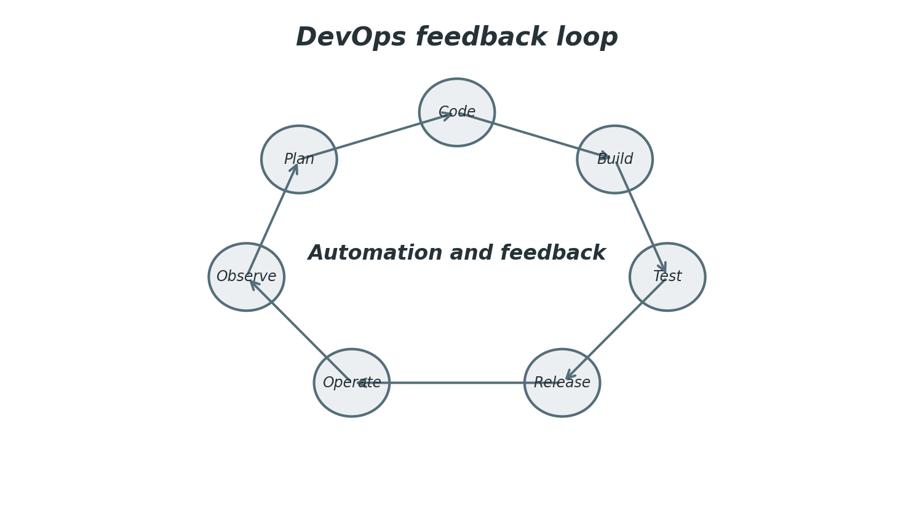
Figure 7. DevOps feedback loop.
Quality should be built into delivery rather than inspected only at the end. Useful practices include code review, automated tests, secure dependency scanning, infrastructure as code, environment consistency, feature flags, release pipelines, and monitoring after deployment. Security should participate early through threat modeling, secure design patterns, secrets management, and vulnerability remediation workflows. This approach is often called shifting left, although teams must also monitor and respond after release.
Automation improves consistency when processes are well understood. Examples include provisioning environments, resetting passwords, deploying applications, collecting logs, updating configuration, responding to standard alerts, and generating compliance evidence. Automation should be designed carefully because a bad script can create problems at machine speed. Good automation includes version control, testing, approvals for risky actions, logging, and rollback options.
A product mindset can improve delivery because teams own outcomes over time rather than handing off a project after launch. Product teams understand users, prioritize backlogs, manage technical debt, measure adoption, and improve services continuously. This model works best when governance provides stable funding, clear objectives, architectural guardrails, and reliable measures of value.
Table 8 provides a compact reference for the practices discussed in this section and names the table so that it can be cited unambiguously in reviews and presentations.
Table 8. Delivery method comparison.
Approach | Strength | Limitation
Waterfall | Clear phases, documentation, and control for stable requirements. | Slow feedback and difficult adaptation when needs change.
Agile | Frequent feedback, incremental delivery, and visible prioritization. | Requires engaged stakeholders and disciplined backlog management.
DevOps | Connects development and operations through automation and shared ownership. | Needs cultural change, tooling maturity, and strong quality practices.
Product model | Teams own outcomes and lifecycle for a product or service. | Requires stable funding, product leadership, and clear performance measures.

Requirements discovery
Requirements should describe problems, outcomes, constraints, and acceptance criteria. Lists of requested features can hide the real need. Discovery techniques include interviews, process observation, prototypes, data analysis, journey maps, and review of support tickets. Better discovery reduces waste because teams can challenge assumptions before design and development effort is committed.
The practical lesson is to connect the topic to ownership, measurement, and continual improvement. A process that is not owned will drift, a platform that is not measured will surprise its operators, and a control that is not reviewed will eventually become either too weak or too burdensome. Harmonious IT management keeps the purpose of each practice visible while adjusting the practice to fit real operating conditions.

Release safety
Release safety increases when changes are small, tested, reversible, observable, and communicated. Feature flags, staged rollout, automated tests, deployment pipelines, and rollback plans reduce risk. Monitoring after deployment is part of release, because successful installation does not prove successful user experience. Teams should watch error rates, latency, support contacts, and business transactions.
The practical lesson is to connect the topic to ownership, measurement, and continual improvement. A process that is not owned will drift, a platform that is not measured will surprise its operators, and a control that is not reviewed will eventually become either too weak or too burdensome. Harmonious IT management keeps the purpose of each practice visible while adjusting the practice to fit real operating conditions.

Technical product management
Product management in IT connects user needs, business value, technical feasibility, and lifecycle ownership. Product managers help prioritize backlogs, define outcomes, coordinate stakeholders, and decide when to improve, replace, or retire capabilities. This role is especially valuable for shared platforms such as identity, integration, data, and collaboration services.
The practical lesson is to connect the topic to ownership, measurement, and continual improvement. A process that is not owned will drift, a platform that is not measured will surprise its operators, and a control that is not reviewed will eventually become either too weak or too burdensome. Harmonious IT management keeps the purpose of each practice visible while adjusting the practice to fit real operating conditions.

11. Emerging Technologies, AI, and the Future of IT
Emerging technologies reshape IT by changing what can be automated, measured, connected, and personalized. Artificial intelligence, low-code platforms, edge computing, internet of things, digital twins, advanced analytics, and privacy-enhancing technologies all create opportunities and risks. The role of IT is to evaluate these technologies through value, feasibility, security, compliance, sustainability, and organizational readiness rather than adopting them only because they are fashionable.
Artificial intelligence is increasingly embedded in everyday tools such as productivity suites, service desks, development environments, analytics platforms, and security products. IT teams need governance for data access, model use, prompts, output validation, auditability, and human oversight. AI can improve support, summarize incidents, detect anomalies, generate code, and assist analysis, but it can also introduce errors, privacy concerns, bias, intellectual property questions, and overreliance.
Skills will remain a central challenge. Modern IT requires a blend of technical depth, business understanding, risk awareness, communication, vendor management, and continual learning. Specialists are still needed in networks, cloud, security, data, architecture, and software engineering, but cross-functional collaboration is equally important. Teams that can explain risk in business language and value in operational language will have greater influence.
Sustainability is becoming a more important part of IT strategy. Hardware lifecycle, energy consumption, cloud efficiency, data retention, printing, device reuse, and responsible disposal all affect environmental impact. Sustainable IT does not automatically mean using less technology; it means using technology more intentionally. Good practices include rightsizing workloads, retiring unused resources, extending device life where safe, and considering energy and materials in procurement decisions.
The future of IT will be more integrated with business strategy. Technology decisions will influence product design, customer trust, employee experience, regulatory posture, resilience, and innovation speed. Organizations should therefore treat IT as a strategic capability with transparent governance, strong architecture, user-centered service design, secure operations, trusted data, and a culture of continual improvement.

AI governance
AI governance should define approved use cases, data access rules, human oversight, evaluation criteria, vendor review, and incident handling for AI-enabled features. The goal is not to block experimentation but to make experimentation responsible. Teams should document assumptions, test outputs, monitor errors, and ensure that high-impact decisions have appropriate review.
The practical lesson is to connect the topic to ownership, measurement, and continual improvement. A process that is not owned will drift, a platform that is not measured will surprise its operators, and a control that is not reviewed will eventually become either too weak or too burdensome. Harmonious IT management keeps the purpose of each practice visible while adjusting the practice to fit real operating conditions.

Low-code and citizen development
Low-code platforms can improve productivity when business users automate local workflows. They can also create shadow IT if ownership, data access, documentation, and lifecycle management are weak. A balanced approach provides templates, training, environment controls, connectors, review paths, and support for solutions that become important to operations.
The practical lesson is to connect the topic to ownership, measurement, and continual improvement. A process that is not owned will drift, a platform that is not measured will surprise its operators, and a control that is not reviewed will eventually become either too weak or too burdensome. Harmonious IT management keeps the purpose of each practice visible while adjusting the practice to fit real operating conditions.

Digital resilience culture
Future-ready IT cultures combine curiosity with operational discipline. Teams experiment, but they also document, monitor, secure, and support what they create. Leaders should reward learning, collaboration, and risk transparency. A culture that hides problems will not become resilient; a culture that investigates problems constructively can improve continuously.
The practical lesson is to connect the topic to ownership, measurement, and continual improvement. A process that is not owned will drift, a platform that is not measured will surprise its operators, and a control that is not reviewed will eventually become either too weak or too burdensome. Harmonious IT management keeps the purpose of each practice visible while adjusting the practice to fit real operating conditions.

12. Implementation Roadmap and Conclusion
A practical IT improvement program should begin with a clear baseline. The baseline should include services, assets, critical applications, pain points, risk register entries, support trends, cloud spend, data quality issues, security gaps, and business priorities. This does not require a year-long assessment. A focused discovery effort can identify the most important strengths, weaknesses, dependencies, and opportunities within a few weeks if the right stakeholders participate.
Figure 8 summarizes a maturity roadmap from stabilization to leadership. The sequence matters because innovation depends on trust. An organization struggling with outages, unclear ownership, weak backups, and uncontrolled access should first stabilize. Once the foundation is reliable, standardization and optimization become easier. Innovation then has a safer platform, and IT can lead with credibility rather than reacting to emergencies.
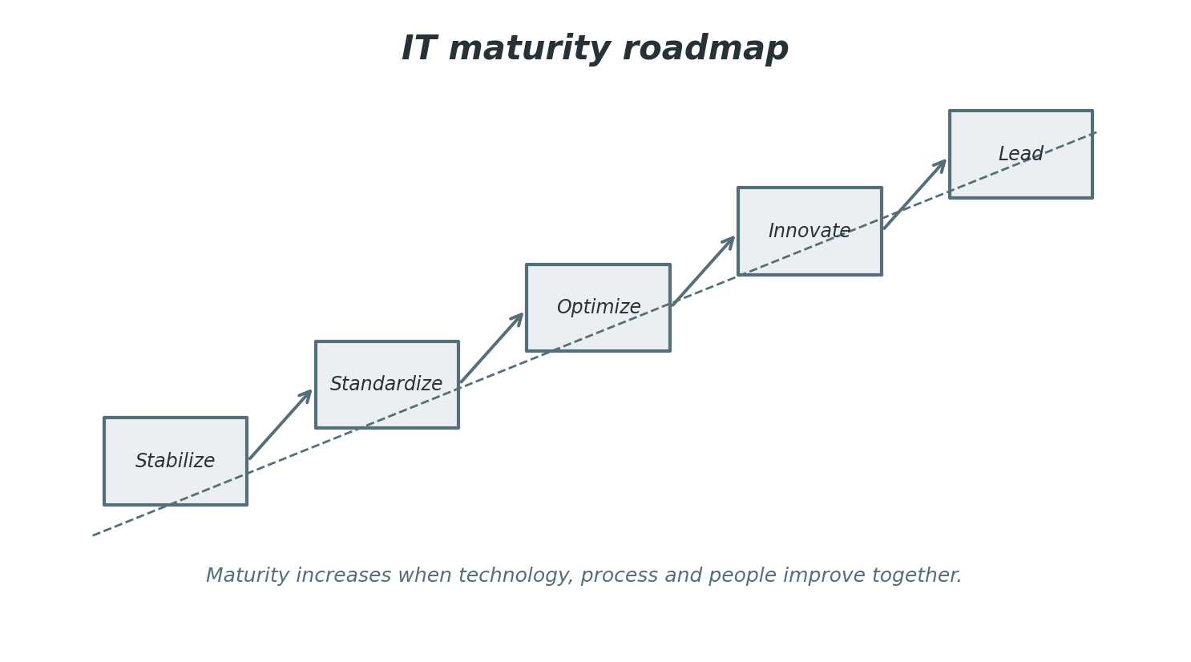
Figure 8. IT maturity roadmap.
Roadmaps should combine quick wins with structural change. Quick wins show progress and build confidence, such as cleaning unused accounts, improving a knowledge article, automating a common request, or fixing a noisy alert. Structural change addresses the deeper operating model, architecture, funding, governance, and skills. Both are necessary. Quick wins without structural change fade quickly; structural change without visible progress loses support.
Communication is a success factor. IT roadmaps should be expressed in business language and supported by evidence. Stakeholders need to understand what will improve, what risks will be reduced, what trade-offs are required, and how success will be measured. Transparent communication also helps manage demand because not every request can be delivered immediately. Prioritization becomes more constructive when criteria are visible.
In conclusion, information technology is a coordinated system of strategy, people, processes, data, controls, and platforms. Its purpose is to enable reliable, secure, and valuable digital services. Organizations that manage IT harmoniously align investments with outcomes, design coherent architecture, protect information, support users, learn from incidents, automate wisely, and keep improving. The result is not only better technology; it is a stronger organization.
Table 10 provides a compact reference for the practices discussed in this section and names the table so that it can be cited unambiguously in reviews and presentations.
Table 10. Roadmap phases and deliverables.
Phase | Purpose | Representative deliverables
Stabilize | Reduce urgent operational risk and restore trust in critical services. | Asset inventory, monitoring baseline, backup tests, top incident fixes.
Standardize | Create repeatable patterns for common technology decisions. | Reference architectures, service catalogue, access model, change categories.
Optimize | Improve cost, performance, automation, and experience. | Cloud cost controls, automation backlog, problem management trends, dashboards.
Innovate | Use data and platforms to create new business capabilities. | Product teams, analytics roadmap, AI governance, reusable integration services.
Lead | Make IT a strategic differentiator and trusted advisor. | Value scorecards, resilience exercises, portfolio governance, skills strategy.

Portfolio discipline
A technology portfolio should distinguish mandatory work, risk reduction, product improvement, platform investment, and experimentation. This classification helps leaders compare unlike requests without pretending every item has the same kind of value. Mandatory work may be driven by regulation or contract. Platform investment may not create immediate revenue but can reduce future delivery cost. Experimentation may have uncertain value but reveal important options.
The practical lesson is to connect the topic to ownership, measurement, and continual improvement. A process that is not owned will drift, a platform that is not measured will surprise its operators, and a control that is not reviewed will eventually become either too weak or too burdensome. Harmonious IT management keeps the purpose of each practice visible while adjusting the practice to fit real operating conditions.

Policy as enablement
Policies should explain desired outcomes and decision rules rather than only prohibitions. For example, a cloud policy can define tagging, logging, encryption, identity, region, and backup expectations. When these rules are built into templates and automated checks, policy becomes an accelerator. Teams no longer have to negotiate every detail because the approved path is visible and repeatable.
The practical lesson is to connect the topic to ownership, measurement, and continual improvement. A process that is not owned will drift, a platform that is not measured will surprise its operators, and a control that is not reviewed will eventually become either too weak or too burdensome. Harmonious IT management keeps the purpose of each practice visible while adjusting the practice to fit real operating conditions.

Vendor accountability
Many IT capabilities are now delivered through vendors and managed services. Governance must therefore include supplier selection, contract review, service level monitoring, exit planning, data handling requirements, and security assurance. Vendor management is not a procurement formality; it is part of operational risk management because external dependencies can affect continuity, privacy, and customer trust.
The practical lesson is to connect the topic to ownership, measurement, and continual improvement. A process that is not owned will drift, a platform that is not measured will surprise its operators, and a control that is not reviewed will eventually become either too weak or too burdensome. Harmonious IT management keeps the purpose of each practice visible while adjusting the practice to fit real operating conditions.

13. Practical Operating Principles

Clarity before tooling
Many technology problems are worsened by buying a tool before clarifying the operating problem. A monitoring platform cannot define service ownership by itself. A ticketing system cannot decide priorities by itself. A data catalogue cannot create data stewardship by itself. Tools amplify practices; they do not replace them. Before selecting tools, teams should define outcomes, roles, workflows, evidence needs, and adoption expectations.
This principle should be translated into local standards and reviewed as the organization changes. The most effective IT practices are not copied mechanically from frameworks; they are adapted responsibly while preserving the intent of reliability, security, value, and learning.

Standardize the common, adapt the exceptional
Standardization reduces cost, risk, and cognitive load. Common laptop builds, identity patterns, logging standards, cloud templates, naming rules, and change categories help teams work consistently. At the same time, the organization must allow justified exceptions because unusual workloads, regulations, and business opportunities may need different solutions. The exception process should be transparent, time-bound where possible, and tied to risk ownership.
This principle should be translated into local standards and reviewed as the organization changes. The most effective IT practices are not copied mechanically from frameworks; they are adapted responsibly while preserving the intent of reliability, security, value, and learning.

Design for recovery
Recovery should be designed into systems from the beginning. Backups, restore procedures, failover, manual workarounds, communication templates, and escalation contacts should be considered during service design, not added after a crisis. Recovery objectives must be agreed with business owners because technology teams cannot decide alone how long a process can be unavailable or how much data loss is acceptable.
This principle should be translated into local standards and reviewed as the organization changes. The most effective IT practices are not copied mechanically from frameworks; they are adapted responsibly while preserving the intent of reliability, security, value, and learning.

Make work visible
Invisible work is hard to prioritize and improve. Queues, roadmaps, risk registers, dashboards, architecture decisions, problem records, and improvement backlogs make work visible. Visibility helps leaders understand trade-offs and helps teams avoid overload. It also reveals when too much effort is being spent on recurring problems that deserve structural fixes.
This principle should be translated into local standards and reviewed as the organization changes. The most effective IT practices are not copied mechanically from frameworks; they are adapted responsibly while preserving the intent of reliability, security, value, and learning.

Treat users as partners
Users are not interruptions to IT work; they are the reason digital services exist. Support interactions, feedback, training questions, and complaints are valuable signals about service quality. IT teams should listen carefully, communicate clearly, and design services around real user journeys. Partnership also means users have responsibilities, such as following security guidance and reporting issues promptly.
This principle should be translated into local standards and reviewed as the organization changes. The most effective IT practices are not copied mechanically from frameworks; they are adapted responsibly while preserving the intent of reliability, security, value, and learning.

Measure outcomes, not only activity
Activity measures can be misleading. A high number of completed tickets may show hard work, but it may also show recurring defects. A large number of changes may show innovation, but it may also show instability. Outcome measures connect activity to value: reduced downtime, faster onboarding, fewer repeated incidents, better satisfaction, lower risk exposure, and more reliable decisions.
This principle should be translated into local standards and reviewed as the organization changes. The most effective IT practices are not copied mechanically from frameworks; they are adapted responsibly while preserving the intent of reliability, security, value, and learning.

14. Implementation Checklists and Working Guidance
A report about information technology becomes more useful when it can be translated into action. The following guidance converts the concepts in earlier sections into working checklists that can be adapted by a small organization, a public institution, a growing company, or an internal department. The checklists are not intended to replace formal audits or specialist advice. They help teams ask the right questions, identify weak points, and create a practical sequence of improvements.
The first step is to decide which services are critical. Criticality should be based on business impact, not technical preference. A collaboration tool may be more important than a specialized application if the organization cannot coordinate work without it. A small database may be critical if it contains legally required records. Once critical services are named, IT can focus inventory, monitoring, backup, access review, and continuity planning on the services that matter most.
The second step is to assign ownership. Every checklist item should have a responsible owner and an evidence source. Without ownership, findings become opinions. Without evidence, progress becomes difficult to prove. Evidence may be a configuration export, a ticket report, a policy, a test result, a screenshot, a system log, a signed review, or a dashboard. The goal is not paperwork for its own sake; the goal is to make good practice visible and repeatable.
The third step is to review progress at a regular cadence. Monthly reviews are often suitable for operational items such as patching, incidents, access requests, and cloud cost. Quarterly reviews may be suitable for risk treatment, architecture standards, supplier performance, continuity tests, and training. Annual reviews are usually not enough for fast-changing environments. The cadence should match the rate at which the risk or service can change.
Table 11. Practical control implementation checklist.
Area | Question | Evidence to collect
Inventory | Do we know the systems, devices, applications, cloud resources, and owners that support critical services? | Asset list, service map, owner register, dependency diagram.
Identity | Are accounts created, changed, reviewed, and removed through a defined workflow? | Joiner-mover-leaver record, access review, privileged account report.
Backup | Can critical data and systems be restored within agreed objectives? | Backup policy, restore test result, recovery objective approval.
Patch and vulnerability | Are exposed and critical vulnerabilities prioritized and tracked to closure? | Scanner output, remediation queue, exception approval, aging report.
Monitoring | Can teams detect outage, performance degradation, suspicious access, and failed jobs? | Alert catalogue, dashboard, event logs, incident examples.
Change | Are risky changes assessed, tested, approved, communicated, and reviewed? | Change record, test evidence, rollback plan, communication record.
Supplier | Are key vendors reviewed for service, security, data handling, and continuity risk? | Contract, service report, assurance document, exit plan.
Awareness | Do users know how to request help and report security concerns? | Training record, communication campaign, reporting statistics.

How to prioritize findings
Prioritization should combine business impact, likelihood, exposure, effort, and dependency. A finding that affects a critical service and has no compensating control should usually outrank a finding that affects a low-value system. However, easy fixes should not be ignored. Completing several small improvements can reduce background risk and build momentum while larger projects are planned. The risk register should show why each decision was made.
The practical result of this guidance is a disciplined but flexible improvement routine. Teams can use it to reduce risk, increase transparency, and show progress without creating unnecessary bureaucracy. The routine should be adjusted to organization size, regulatory environment, service criticality, and available skills.

How to write improvement actions
An improvement action should be specific enough that another person can understand what done means. Weak wording says improve backup. Strong wording says test restoration of the finance database from immutable backup and record whether the recovery point objective and recovery time objective were met. Clear actions reduce misunderstanding and make reporting more credible. Each action should have an owner, target date, success measure, and dependency note.
The practical result of this guidance is a disciplined but flexible improvement routine. Teams can use it to reduce risk, increase transparency, and show progress without creating unnecessary bureaucracy. The routine should be adjusted to organization size, regulatory environment, service criticality, and available skills.

How to handle exceptions
Exceptions are normal in real environments, but they should be controlled. A system may be unable to meet a standard because of vendor limitations, legacy dependencies, or urgent business needs. The exception should document the reason, risk, compensating controls, approval, review date, and retirement or remediation plan. Permanent exceptions often signal that the standard is unrealistic or that a deeper modernization decision is being delayed.
The practical result of this guidance is a disciplined but flexible improvement routine. Teams can use it to reduce risk, increase transparency, and show progress without creating unnecessary bureaucracy. The routine should be adjusted to organization size, regulatory environment, service criticality, and available skills.

How to keep checklists alive
Checklists lose value when they are treated as annual paperwork. They should be integrated with service reviews, change management, architecture design, procurement, project closure, and incident learning. When a new lesson is learned, the checklist should be updated. When a checklist question produces no useful decision, it should be improved or removed. Living checklists are part of organizational memory.
The practical result of this guidance is a disciplined but flexible improvement routine. Teams can use it to reduce risk, increase transparency, and show progress without creating unnecessary bureaucracy. The routine should be adjusted to organization size, regulatory environment, service criticality, and available skills.

How to communicate results
Different audiences need different levels of detail. Executives need risk, value, trends, and decisions. Service owners need actions, dependencies, and user impact. Engineers need technical detail. Auditors need evidence. Users need practical guidance and status. Good reporting translates the same facts into the language needed by each audience without hiding uncertainty or exaggerating certainty.
The practical result of this guidance is a disciplined but flexible improvement routine. Teams can use it to reduce risk, increase transparency, and show progress without creating unnecessary bureaucracy. The routine should be adjusted to organization size, regulatory environment, service criticality, and available skills.

How to measure maturity honestly
Maturity is not a trophy. It is a description of how reliably the organization can produce desired outcomes. A team should not claim high maturity because a policy exists if the policy is not followed. Honest maturity assessment looks for repeatability, evidence, ownership, measurement, and improvement. It is better to recognize a weakness early than to discover it during an outage or audit.
The practical result of this guidance is a disciplined but flexible improvement routine. Teams can use it to reduce risk, increase transparency, and show progress without creating unnecessary bureaucracy. The routine should be adjusted to organization size, regulatory environment, service criticality, and available skills.

15. Sample IT Assessment Scorecard
A scorecard helps summarize current capability and guide improvement conversations. The scores should not be used to punish teams. They should reveal where support, funding, clarity, or architectural change is needed. A simple five-level scale is sufficient for many organizations: initial, repeatable, defined, managed, and improving. The important point is to record the evidence behind each score and the action that would move the area forward.
The scorecard in Table 12 can be used during workshops. Each row should be discussed with service owners, security representatives, operations staff, business stakeholders, and leadership. A workshop should identify disagreements because disagreement often reveals unclear ownership or different assumptions. For example, a business unit may believe a service is highly critical while IT has no recovery objective recorded. That gap is an improvement opportunity.
Table 12. IT assessment scorecard template.
Capability | Initial condition | Target condition
Service ownership | Services are supported by technical teams but ownership is informal. | Each critical service has a named owner, metrics, dependencies, and review cadence.
Asset visibility | Inventories exist in separate tools and are not consistently reconciled. | Assets are linked to services, owners, criticality, lifecycle status, and risk.
Access management | Access requests are handled manually with inconsistent review. | Access follows role models, approval workflows, periodic review, and automation.
Operational monitoring | Alerts are configured but noisy and not mapped to business services. | Monitoring combines technical signals with service impact and escalation paths.
Data quality | Reports exist but definitions and ownership are inconsistent. | Critical data elements have owners, definitions, quality rules, and issue tracking.
Cloud governance | Teams can create resources but cost and security guardrails are uneven. | Landing zones, policy checks, tags, budgets, and reference patterns are adopted.
Security response | Incident response exists but exercises and lessons learned are irregular. | Playbooks, exercises, communication, and corrective actions are measured.
Continuity | Backups run but restoration evidence is incomplete. | Recovery objectives are agreed, tested, and reported for critical services.
Delivery quality | Releases depend on manual checks and expert knowledge. | Pipelines, automated tests, release controls, and observability are standard.
User experience | Support is responsive but feedback is not systematically analyzed. | Experience metrics and user feedback guide service improvements.

Interpreting the scorecard
A scorecard should be interpreted as a map, not a final judgment. Low scores are not automatically failures; they may reflect new services, limited budgets, or rational trade-offs. High scores should be supported by evidence. The most important insight is the pattern across capabilities. If many areas are weak because ownership is unclear, an operating model change may be more valuable than buying another tool.
This assessment approach supports the harmonious style of IT management used in this report: transparent enough for leadership, practical enough for teams, and flexible enough to adapt as services and risks change.

Turning scores into a roadmap
After scoring, the team should select a small number of improvement themes. Too many initiatives create overload and dilute progress. A good roadmap might include one stability theme, one security theme, one data theme, and one user experience theme. Each theme should include actions that can be completed within the next quarter and structural actions that may require longer investment.
This assessment approach supports the harmonious style of IT management used in this report: transparent enough for leadership, practical enough for teams, and flexible enough to adapt as services and risks change.

Maintaining momentum
Momentum depends on visible progress. The scorecard should be reviewed periodically, and completed actions should be celebrated. When an action is delayed, the reason should be discussed openly. Delays may result from dependency, funding, unclear decision rights, vendor limitation, or underestimated effort. Understanding the cause of delay is more useful than simply changing dates.
This assessment approach supports the harmonious style of IT management used in this report: transparent enough for leadership, practical enough for teams, and flexible enough to adapt as services and risks change.

Avoiding score inflation
Score inflation happens when teams rate themselves based on intention rather than practice. To avoid this, require examples. If change management is scored as managed, ask for recent change records, failed-change analysis, emergency change review, and user communication. If data governance is scored as defined, ask for actual definitions, owners, quality rules, and issue history. Evidence keeps the scorecard honest.
This assessment approach supports the harmonious style of IT management used in this report: transparent enough for leadership, practical enough for teams, and flexible enough to adapt as services and risks change.

16. Glossary of Core IT Terms
A shared vocabulary reduces confusion between technical and non-technical stakeholders. The glossary in Table 13 names common IT terms in concise language. In practice, a glossary should be adapted to the organization because different industries use different names for similar concepts. The aim is not academic precision alone; the aim is clearer decisions, better documentation, and fewer misunderstandings during incidents, projects, audits, and service reviews.
Table 13. Glossary of core IT terms.
Term | Meaning in practical IT management
Architecture | The structured design of capabilities, applications, data, integrations, infrastructure, and controls.
Availability | The ability of a service to be accessible and usable when required by users.
Change | A planned modification to a service, system, configuration, process, or supporting component.
Cloud | On-demand access to configurable computing resources delivered through service models and provider platforms.
Configuration | A documented setting or relationship that affects how a service or component behaves.
Control | A safeguard or practice designed to reduce risk or improve reliability, security, or compliance.
Data lineage | The record of where data comes from, how it moves, and how it is transformed.
Identity | The representation of a person, service, device, or process used to control access.
Incident | An event that disrupts or threatens normal service, security, or business operation.
Resilience | The ability to resist disruption, absorb impact, recover, and improve after events.
Service catalogue | A user-facing description of available IT services and how to request or support them.
Technical debt | Future cost and risk created by shortcuts, outdated technology, weak documentation, or deferred remediation.

Using vocabulary in governance
Vocabulary should appear consistently in policies, service catalogues, architecture documents, training, and reports. If the same concept is called an application in one meeting, a system in another, and a platform in a third, accountability becomes blurred. Clear vocabulary helps leaders compare risks and investments because they can see whether people are discussing the same type of object.
The glossary should be treated as a starting point. Teams should add local terms, retire confusing terms, and include examples from real services so that the vocabulary remains useful rather than theoretical.

Using vocabulary in incidents
During incidents, language must be especially clear. Teams should distinguish symptoms from causes, incidents from problems, workarounds from permanent fixes, and restoration from full recovery. Ambiguous language can lead to poor decisions, such as announcing that a service is fixed when only a temporary workaround is in place. Precise language improves coordination and trust.
The glossary should be treated as a starting point. Teams should add local terms, retire confusing terms, and include examples from real services so that the vocabulary remains useful rather than theoretical.

Using vocabulary in projects
Projects benefit from shared terms for scope, requirements, acceptance criteria, dependency, risk, constraint, and benefit. Misunderstood terms create rework. A team may believe a requirement is optional while a business owner believes it is mandatory. A shared vocabulary does not remove all disagreement, but it helps disagreement surface early enough to be resolved constructively.
The glossary should be treated as a starting point. Teams should add local terms, retire confusing terms, and include examples from real services so that the vocabulary remains useful rather than theoretical.

17. Study and Review Questions

Strategic alignment
Which three business outcomes should IT support most strongly during the next year, and which current technology constraints make those outcomes harder to achieve?
A useful answer should include current evidence, desired outcome, responsible owner, risk or value rationale, and a next action. The answer does not need to be perfect. It needs to be honest enough to guide improvement and specific enough to be reviewed later.

Service ownership
Which critical services have clearly named owners, and which services depend on informal knowledge or undocumented relationships?
A useful answer should include current evidence, desired outcome, responsible owner, risk or value rationale, and a next action. The answer does not need to be perfect. It needs to be honest enough to guide improvement and specific enough to be reviewed later.

Risk visibility
Which technology risks are accepted, which are being treated, and which are not yet owned by an accountable decision maker?
A useful answer should include current evidence, desired outcome, responsible owner, risk or value rationale, and a next action. The answer does not need to be perfect. It needs to be honest enough to guide improvement and specific enough to be reviewed later.

Cloud governance
Which cloud resources have clear purpose, owner, cost center, security classification, backup need, and lifecycle status?
A useful answer should include current evidence, desired outcome, responsible owner, risk or value rationale, and a next action. The answer does not need to be perfect. It needs to be honest enough to guide improvement and specific enough to be reviewed later.

Data trust
Which reports are used for important decisions, and can stakeholders explain the definitions, data sources, quality rules, and refresh frequency behind them?
A useful answer should include current evidence, desired outcome, responsible owner, risk or value rationale, and a next action. The answer does not need to be perfect. It needs to be honest enough to guide improvement and specific enough to be reviewed later.

Incident readiness
When was the last realistic incident or continuity exercise, what was learned, and which corrective actions remain open?
A useful answer should include current evidence, desired outcome, responsible owner, risk or value rationale, and a next action. The answer does not need to be perfect. It needs to be honest enough to guide improvement and specific enough to be reviewed later.

User experience
Which repeated support issues create the greatest frustration for users, and would automation, training, design change, or problem management reduce them?
A useful answer should include current evidence, desired outcome, responsible owner, risk or value rationale, and a next action. The answer does not need to be perfect. It needs to be honest enough to guide improvement and specific enough to be reviewed later.

Delivery quality
Which release activities are automated, which depend on manual expert judgment, and which controls provide confidence after deployment?
A useful answer should include current evidence, desired outcome, responsible owner, risk or value rationale, and a next action. The answer does not need to be perfect. It needs to be honest enough to guide improvement and specific enough to be reviewed later.

Security culture
Do employees know how to report suspicious activity, and do they believe reporting will lead to help rather than blame?
A useful answer should include current evidence, desired outcome, responsible owner, risk or value rationale, and a next action. The answer does not need to be perfect. It needs to be honest enough to guide improvement and specific enough to be reviewed later.

Future readiness
Which emerging technologies are already entering the organization through vendors or user tools, and what governance is needed before they become critical?
A useful answer should include current evidence, desired outcome, responsible owner, risk or value rationale, and a next action. The answer does not need to be perfect. It needs to be honest enough to guide improvement and specific enough to be reviewed later.
These questions can be used for classroom discussion, management workshops, audit preparation, or project initiation. They reinforce the central message of the document: IT should be managed as a living system of value, reliability, security, data, service, and learning.

18. Example One-Year IT Roadmap
A one-year roadmap should translate strategy into a sequence that teams can actually deliver. The roadmap should not be a wish list of every requested improvement. It should identify the few themes that matter most, name dependencies, and reserve capacity for operational work. A realistic roadmap recognizes that IT teams must run existing services while improving them. It also recognizes that business priorities may change, so the roadmap should be reviewed regularly rather than frozen for the entire year.
The example in Table 14 assumes an organization that wants to improve reliability, security, cloud governance, data quality, user experience, and delivery discipline. The order begins with visibility and stabilization, then moves toward standardization and optimization. This sequence is intentionally practical. Teams cannot optimize what they cannot see, and they cannot innovate confidently when foundational services remain fragile.
Table 14. Example one-year IT roadmap.
Quarter | Main theme | Key deliverables
Quarter 1 | Visibility and stabilization | Critical service list, owner register, backup restore tests, incident trend review, privileged access review.
Quarter 1 | User support basics | Service catalogue draft, top knowledge articles, request categories, satisfaction baseline.
Quarter 2 | Standards and guardrails | Cloud landing zone rules, endpoint standard, logging baseline, change categories, architecture review template.
Quarter 2 | Security hygiene | Vulnerability prioritization model, multi-factor coverage review, phishing reporting process, security awareness refresh.
Quarter 3 | Optimization and automation | Automated common requests, cloud cost dashboards, alert tuning, problem management for recurring incidents.
Quarter 3 | Data trust | Data owner assignments, glossary for critical data elements, dashboard certification, quality issue process.
Quarter 4 | Resilience and delivery | Continuity exercise, incident playbook update, release pipeline improvements, service review scorecards.
Quarter 4 | Future readiness | AI use policy, low-code governance, skills plan, next-year investment proposal.

Quarterly review rhythm
At the end of each quarter, leaders and service owners should review delivery, risk movement, user feedback, and new demand. The review should ask what changed, what was learned, what remains blocked, and whether priorities still make sense. A roadmap that never changes may be ignoring reality. A roadmap that changes every week may lack governance. The quarterly rhythm balances adaptability with discipline.
This roadmap example should be adapted to local context. A highly regulated organization may prioritize evidence and control design earlier. A fast-growing company may prioritize identity, onboarding, cloud cost, and architecture guardrails. A public institution may prioritize accessibility, procurement transparency, continuity, and data retention. The structure is flexible, but the principle remains the same: align improvement work with value, risk, ownership, and measurable outcomes.

Capacity planning
Roadmap planning should include realistic capacity. Operational teams must handle incidents, requests, maintenance, supplier issues, security work, and unexpected events. If all capacity is assigned to projects, normal operations will suffer and project quality will decline. A common practice is to reserve explicit capacity for unplanned work, technical debt, and improvement actions discovered during incidents or service reviews.
This roadmap example should be adapted to local context. A highly regulated organization may prioritize evidence and control design earlier. A fast-growing company may prioritize identity, onboarding, cloud cost, and architecture guardrails. A public institution may prioritize accessibility, procurement transparency, continuity, and data retention. The structure is flexible, but the principle remains the same: align improvement work with value, risk, ownership, and measurable outcomes.

Dependency management
Most IT roadmap items depend on other teams. Cloud guardrails may require security input, finance tagging, network design, and developer adoption. Data quality may require business owners, analysts, and application teams. Continuity exercises may require communications, legal, suppliers, and business process owners. Dependencies should be named early so that the roadmap reflects coordinated work rather than isolated tasks.
This roadmap example should be adapted to local context. A highly regulated organization may prioritize evidence and control design earlier. A fast-growing company may prioritize identity, onboarding, cloud cost, and architecture guardrails. A public institution may prioritize accessibility, procurement transparency, continuity, and data retention. The structure is flexible, but the principle remains the same: align improvement work with value, risk, ownership, and measurable outcomes.

Value tracking
Each roadmap theme should have a value hypothesis. For example, alert tuning should reduce noise and improve response time. Knowledge articles should reduce repeated tickets and improve self-service. Access review should reduce excessive privilege. Cloud cost dashboards should reduce waste and improve accountability. Tracking these hypotheses helps show whether improvements are producing outcomes rather than merely completing activities.
This roadmap example should be adapted to local context. A highly regulated organization may prioritize evidence and control design earlier. A fast-growing company may prioritize identity, onboarding, cloud cost, and architecture guardrails. A public institution may prioritize accessibility, procurement transparency, continuity, and data retention. The structure is flexible, but the principle remains the same: align improvement work with value, risk, ownership, and measurable outcomes.

Sustaining improvement
A roadmap creates value only if practices become part of normal work. A one-time access review is useful, but a recurring review process is better. A one-time restore test is useful, but scheduled restoration exercises are better. A one-time service catalogue draft is useful, but a maintained catalogue is better. The final measure of success is whether the organization keeps improving after the project attention moves elsewhere.
This roadmap example should be adapted to local context. A highly regulated organization may prioritize evidence and control design earlier. A fast-growing company may prioritize identity, onboarding, cloud cost, and architecture guardrails. A public institution may prioritize accessibility, procurement transparency, continuity, and data retention. The structure is flexible, but the principle remains the same: align improvement work with value, risk, ownership, and measurable outcomes.

References
Center for Internet Security. CIS Critical Security Controls Version 8.1. Center for Internet Security, 2025.
ISACA. COBIT resources and framework materials for governance and management of enterprise information and technology. ISACA, accessed 2026.
ISO. ISO/IEC 27001:2022 Information security management systems: Requirements. International Organization for Standardization, 2022.
National Institute of Standards and Technology. The NIST Cybersecurity Framework (CSF) 2.0. NIST CSWP 29, February 26, 2024.
National Institute of Standards and Technology. The NIST Definition of Cloud Computing. NIST Special Publication 800-145, September 2011.
National Institute of Standards and Technology. Incident Response Recommendations and Considerations for Cybersecurity Risk Management: A CSF 2.0 Community Profile. NIST Special Publication 800-61 Revision 3, April 2025.
National Institute of Standards and Technology. Artificial Intelligence Risk Management Framework (AI RMF 1.0). NIST AI 100-1, January 2023.
PeopleCert. ITIL 4 Foundation framework overview, including the service value system and four dimensions of service management. PeopleCert, accessed 2026.

